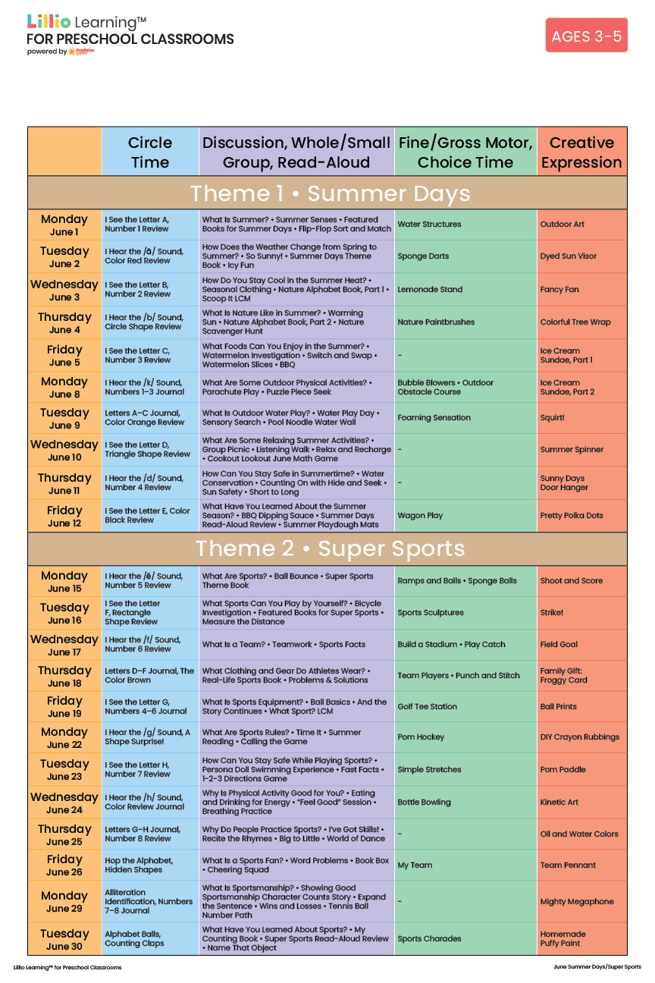
Add Your Name/Logo Here
June 2026

